***ABHISHEK SHARMA***

***500067644***

***DEVOPS B1***

**BRM EXP-8**

**Project name: - Demo_Class**

**Class name: - First.java**

**Input Code: -**

**package** selenium_test;

**import** org.openqa.selenium.By;

**import** org.openqa.selenium.Keys;

**import** org.openqa.selenium.WebDriver;

**import** org.openqa.selenium.chrome.ChromeDriver;

**public** **class** First {

**public** **static** **void** main(String[] args) {

// declaration and instantiation of objects/variables

System.*setProperty*("webdriver.chrome.driver", "D:\\chromedriver_win32\\chromedriver.exe");

WebDriver driver=**new** ChromeDriver();

// Launch website

driver.navigate().to("http://www.google.com/");

// Click on the search text box and send value

driver.findElement(By.*name*("q")).sendKeys("DEVOPS ABHISHEK SHARMA");

// Click on the search button

//driver.findElement(By.name("btnK")).click();

driver.findElement(By.*name*("q")).sendKeys(Keys.***ENTER***);

}

}

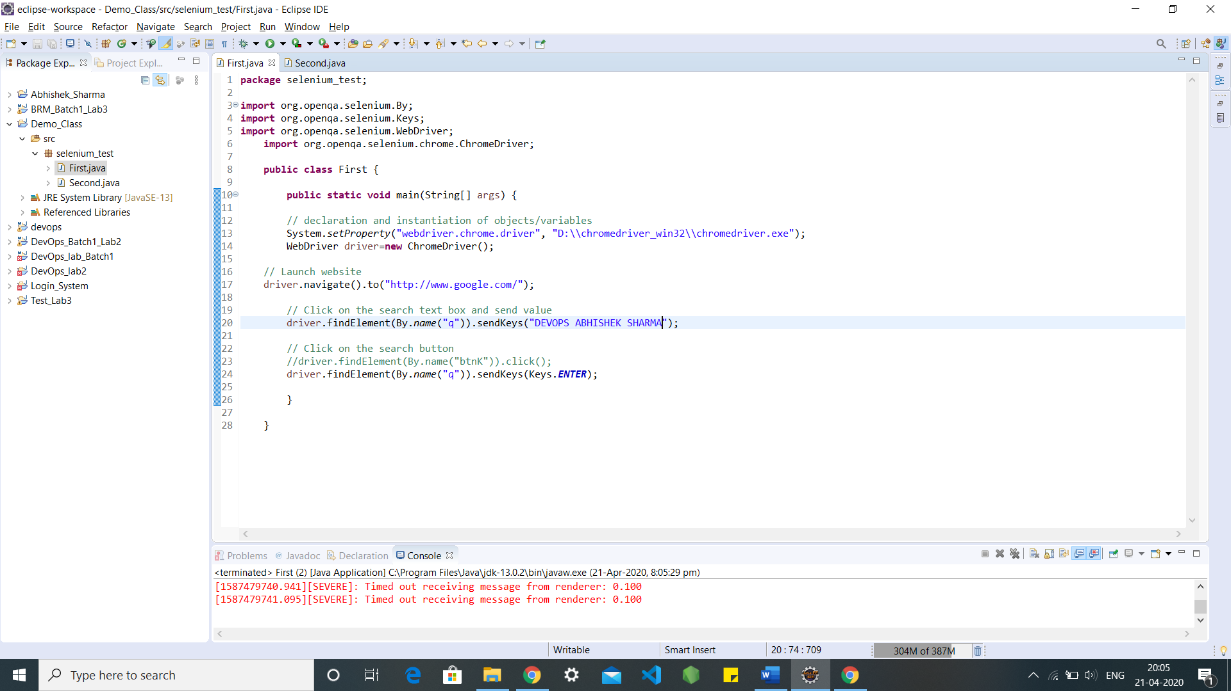

**Output Screen: -**

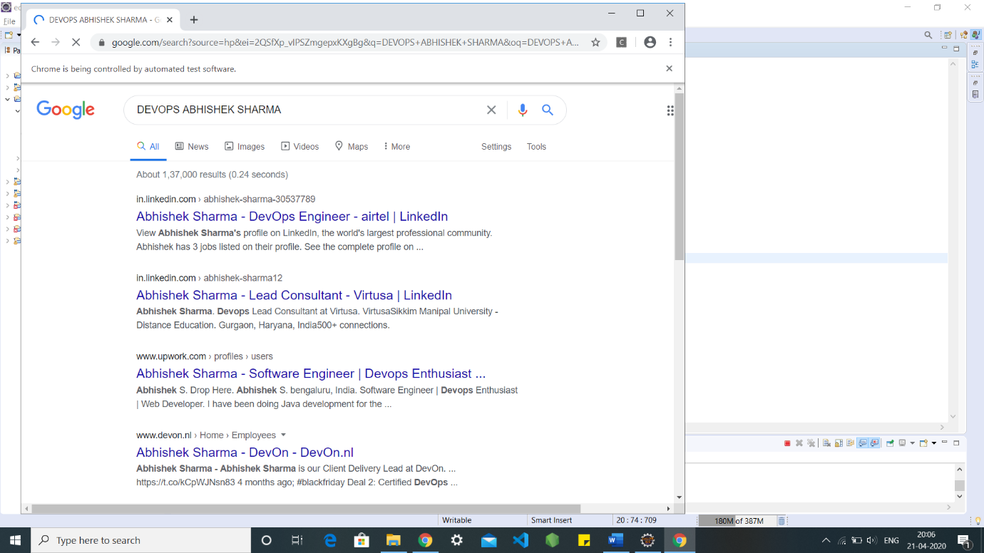

**Class name: - Second.java**

**Input Code: -**

**package** selenium_test;

**import** org.openqa.selenium.WebDriver;

**import** org.openqa.selenium.chrome.ChromeDriver;

**public** **class** Second{

**public** **static** **void** main(String[] args) {

// System Property for Chrome Driver

System.*setProperty*("webdriver.chrome.driver","D:\\chromedriver_win32\\chromedriver.exe");

// Instantiate a ChromeDriver class.

WebDriver driver=**new** ChromeDriver();

// Storing the Application Url in the String variable

String url = ("https://www.google.co.in/");

//Launch the ToolsQA WebSite

driver.get(url);

// Storing Title name in the String variable

String title = driver.getTitle();

// Storing Title length in the Int variable

**int** titleLength = driver.getTitle().length();

// Printing Title & Title length in the Console window

System.***out***.println("Title of the page is : " + title);

System.***out***.println("Length of the title is : "+ titleLength);

// Storing URL in String variable

String actualUrl = driver.getCurrentUrl();

**if** (actualUrl.equals("https://www.google.co.in/"))

{

System.***out***.println("Verification Successful - The correct Url is opened.");

}

**else**{

System.***out***.println("Verification Failed - An incorrect Url is opened.");

}

// Storing Page Source in String variable

String pageSource = driver.getPageSource();

// Storing Page Source length in Int variable

**int** pageSourceLength = pageSource.length();

// Printing length of the Page Source on console

System.***out***.println("Total length of the Pgae Source is : " + pageSourceLength);

//Closing browser

driver.close();

}

}

**Output Screen: -**

